- Find Total Orders
SELECT COUNT(DISTINCT order_id) AS total_orders
FROM orders;
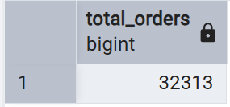

- Find Total Revenue
SELECT
SUM(price_usd) AS total_revenue
FROM orders;
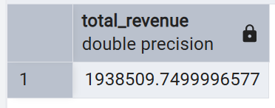
- Find Average Order Value
SELECT
AVG(price_usd) AS average_order_value
FROM orders;
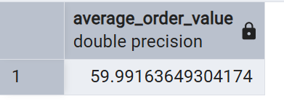
- Find Monthly Revenue
SELECT
EXTRACT(YEAR FROM created_at) AS year,
EXTRACT(MONTH FROM created_at) AS month,
COUNT(DISTINCT order_id) AS total_orders,
SUM(price_usd) AS revenue
FROM orders
GROUP BY
EXTRACT(YEAR FROM created_at),
EXTRACT(MONTH FROM created_at)
ORDER BY
year,
month;

- Find Orders by Product
SELECT
p.product_name,
COUNT(DISTINCT oi.order_id) AS total_orders
FROM order_items oi
JOIN products p
ON oi.product_id = p.product_id
GROUP BY p.product_name
ORDER BY total_orders DESC;
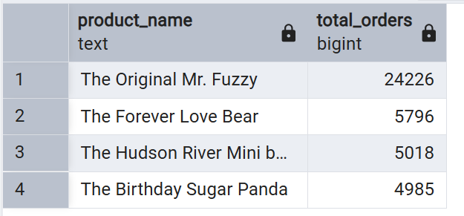
- Find Revenue by Product
SELECT
p.product_name,
SUM(oi.price_usd) AS revenue
FROM order_items oi
JOIN products p
ON oi.product_id = p.product_id
GROUP BY p.product_name
ORDER BY revenue DESC;
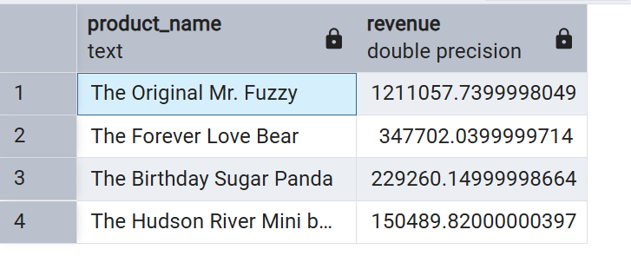
- Find Revenue by Traffic Source
SELECT
s.utm_source,
COUNT(DISTINCT s.website_session_id) AS sessions,
COUNT(DISTINCT o.order_id) AS orders
FROM sessions s
LEFT JOIN orders o
ON s.website_session_id = o.website_session_id
GROUP BY s.utm_source
ORDER BY sessions DESC;

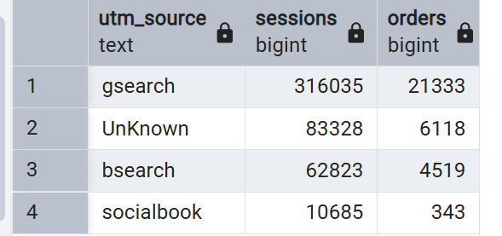

- Calculate Conversion Rate by Traffic Source
SELECT
s.utm_source,
COUNT(DISTINCT s.website_session_id) AS sessions,
COUNT(DISTINCT o.order_id) AS orders,

ROUND(
COUNT(DISTINCT o.order_id)::NUMERIC
/ NULLIF(COUNT(DISTINCT s.website_session_id), 0) * 100,
2
) AS conversion_rate
FROM sessions s
LEFT JOIN orders o
ON s.website_session_id = o.website_session_id
GROUP BY s.utm_source
ORDER BY conversion_rate DESC;
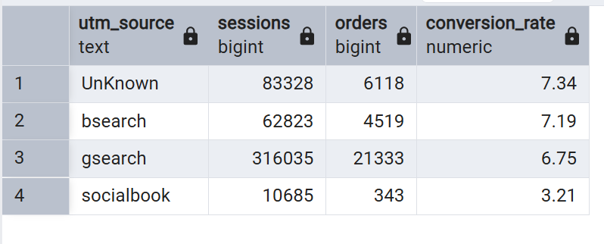
- Find Top 3 Products by Revenue
SELECT
p.product_name,
SUM(oi.price_usd) AS revenue
FROM order_items oi
JOIN products p
ON oi.product_id = p.product_id
GROUP BY p.product_name
ORDER BY revenue DESC
LIMIT 3;
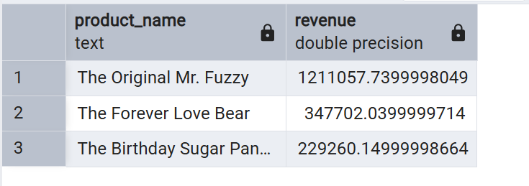

- Find Monthly Revenue Growth
WITH monthly_sales AS (
SELECT
DATE_TRUNC('month', created_at) AS month,
SUM(price_usd) AS revenue
FROM orders
GROUP BY 1
),

previous_month AS (
SELECT
month,
revenue,
LAG(revenue) OVER (
ORDER BY month
) AS previous_revenue
FROM monthly_sales
)

SELECT
month,
revenue,
previous_revenue,

ROUND(
(revenue - previous_revenue)
/ NULLIF(previous_revenue, 0) * 100,
2
) AS growth_percentage
FROM previous_month
ORDER BY month;



